1. Display all the jobs available in the marketplace (jobs that owners have advertised for service suppliers).

Option 1: Query & Output

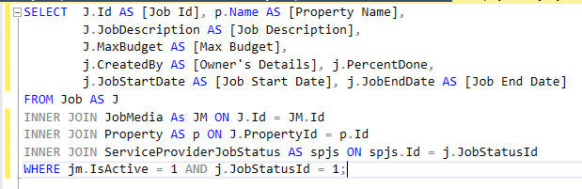



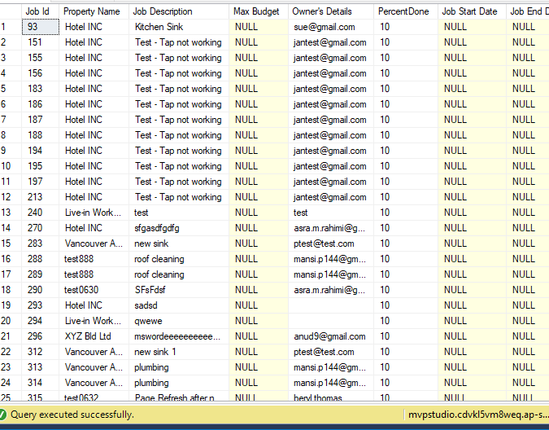



Total = 63 records

Option 2: Query & output

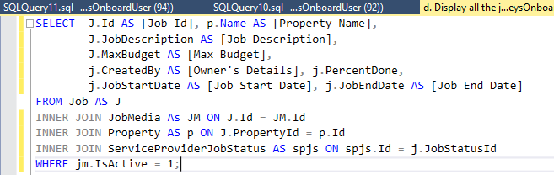



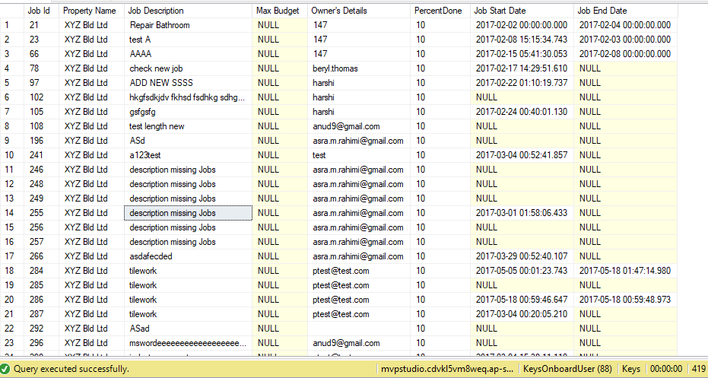



Total = 419 records

Which query is correct option 1 or option 2 & why?

Why there is 10% done in “Percent Done” Column? Even though those jobs haven’t started yet!! It is current advertised jobs.